 | IoT Korea Exhibition 2016  Oct. 12(Wed)~14(Fri), 2016 / COEX, Seoul, Korea
1. Exhibitor information
Company Name
Address | Zip Code ( - )
Tel |  |  |  |  | Fax
Website | www.
Contact |  |  |  |  | Title
E-mail |  |  |  |  | M.P.

2. Booth type & Price Information[1booth : 3mx3m= 9sqm]
Booth Type | Raw Space  (Min. size 2booths) | Shell Scheme Package  (Min. size 1booth)
Price | USD 2,500 / 1booth | USD 3,000 / 1booth

3. Participation Fee for Exhibitions Space
Booth Type | Booth Quantity |  | Total
▪ Raw Space |  | Booth(s) | USD
▪ Shell Scheme Package |  | Booth(s) | USD

4. Products to be exhibited

5. Payment Schedule
The Exhibitor agrees to the following payment Schedule :
- 50% of Total amount should be paid within 7 days.
- The final balance should be paid no later than August. 26, 2016.

Name |  |  | Title |  | Date
Authorized Signatory
& Company Stamp

IoT Korea Exhibition 2016 Organizer Office l Tel : +82-2-555-7153 , E-mail. jykoo@kfairs.com

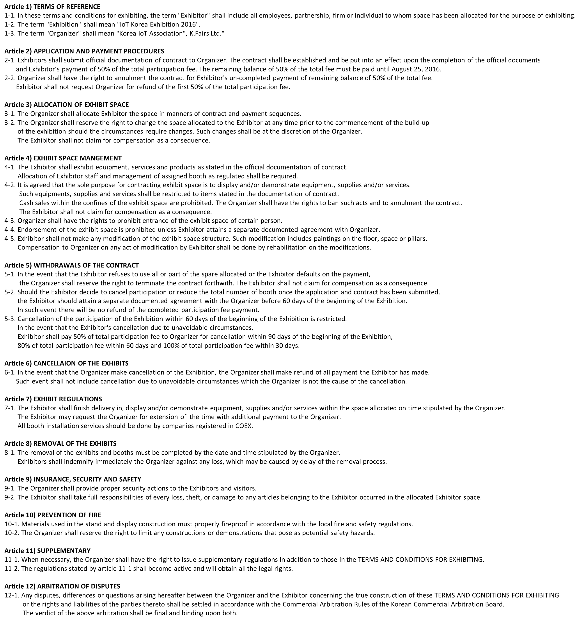
IoT Korea Exhibition 2016 Organizer Office l Tel : +82-2-555-7153 , E-mail. jykoo@kfairs.com

